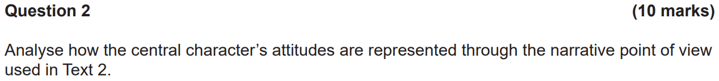

Through a third-person point of view, Text 2, an extract from the short story “Nullius” by Amanda Curtin, demonstrates a carefree and serene attitude towards life during childhood as well as a negligent attitude towards responsibilities. Curtin explores how often during childhood there are minimal responsibilities, stresses or burdens, and how those that exist are often neglected.

By repeatedly referring to the central character as “she” and “her”, this third person point of view creates a sense of emotional detachment between her and Curtin, conveying the idea that times have changed and now there are more responsibilities. Through sensory detail, Curtin vividly describes the central character’s experiences as she wanders through nature, creating a relaxed tone and atmosphere as nature often has connotations with peace and tranquillity. This can be seen in a series of statements, such as “threading through slimy reeds” and “bare feet squelching”, building a carefree attitude towards childhood. The emotional distance between the central character and Curtin created through the third person point of view emphasises the idea that times have changed and that now the responsibilities are more prominent.

Additionally, selective syntax is used when Curtin writes “She hasn’t brought the net and bucket today”. This sentence is separated from other paragraphs, creating emphasis on this sentence. It emphasises that during childhood, we often neglect rules and responsibilities. Through a third person point of view that distances the author to the childhood portrayed in the text, this adds to Curtin’s carefree attitude towards childhood and a negligent attitude towards responsibilities. Also, through the central character’s actions, Curtin characterises her as neglecting here responsibilities to her little brother. This is evident when she writes “Or she could turn back. check on her brother – that’s what she should do. Instead, she…”. This portrays the idea of childhood being a time where we don’t feel a sense of responsibility, creating a negligent attitude towards responsibilities. Furthermore, when Curtin writes “twirls until… her head is full of air and bits of words”, this use of metaphor signifies the lack of stress and hardship during childhood. In adulthood, we are too cooped up in the stresses of life to live freely with no mental burden. Thoughts often flood our heads, so this metaphor and third person point of view work to emphasise a carefree attitude towards life during childhood.



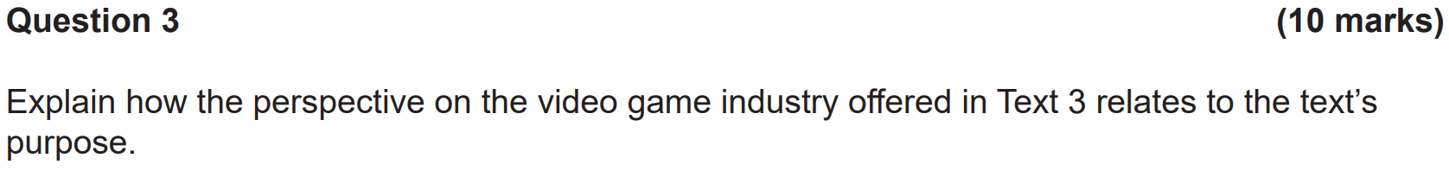

The extract from the open letter by Ron Curry represents the viewpoint that the video game industry has potential to contribute to the advancement of society, particularly in STEM. This comes from the context that values the development of video games and the belief that the development of video games is advantageous.

Throughout the whole text, a formal and knowledgeable voice is evident. This is created through the usage of a formal tone. This can be seen when Curry writes jargon such as “conference”, “linear”, “credibility”, “innovative”, “technical” and “sector”. This use of jargon reinforces to viewers that Curry is aiming to create a formal tone. This is evident as generally readers would expect this sort of language used in a formal setting. Furthermore, the use of statistics when Curry writes “We know that 68 per cent of Australians play video games” and “Ninety-eight per cent of homes with children under the age of 18 have computer games” shows that Curry is knowledgeable of his field of work. Also, writing “We know that…” implies that Curry sees these statistics as second nature, creating a knowledgeable tone as people would generally not be as familiar with such statistics. Additionally, when Curry writes “Just look at the success of coding clubs…”, he uses evidence to substantiate his point regarding the positive impact of video games. As such, a formal and knowledgeable tone is created, enforcing Curry’s perspective that video games have potential in STEM as it shows his seriousness in approaching the topic. Curry believes that video games aren’t as time-wasting as society often make them out to be.

In addition to this, the use of rhetorical questions and repetition highlights the positive influence of video games on society. This can be seen when Curry writes “Why is it then that games don’t seem to earn the credibility that film and TV receives?”, causing the reader to question why video games aren’t seen as positively as film and TV, increasing the credibility and improving the reputation of the video game industry. Also, throughout the text, Curry has repeated usage of the word “innovation”, as seen through sentences such as “… also highly innovative and technical…” and “We know that Australia has a strong appetite innovation…”. The word “innovation” connotes technological advancement and progress towards a more advanced society, particularly in STEM. This use of repetition works to connect such innovation with video games, implying that video games can contribute towards societal development and as such Curry’s perspective that video games hold potential in STEM is endorsed.



Through the adoption of a nostalgic and reminiscent voice, the excerpt from Tim Rogers’ autobiography represents a close, loving and respectful father-son relationship which is grounded in a shared history and a love of football.

Rogers reflects past memories with his father, reminiscing the times full of fond memories. Sensory detail is used to vividly describe these memories, using words to vividly describe these memories such as “fluffy innards” and “freezing trek”. This shows the emotional significance of these memories to Rogers, contributing to a nostalgic and reminiscent tone.

[To be continued…]

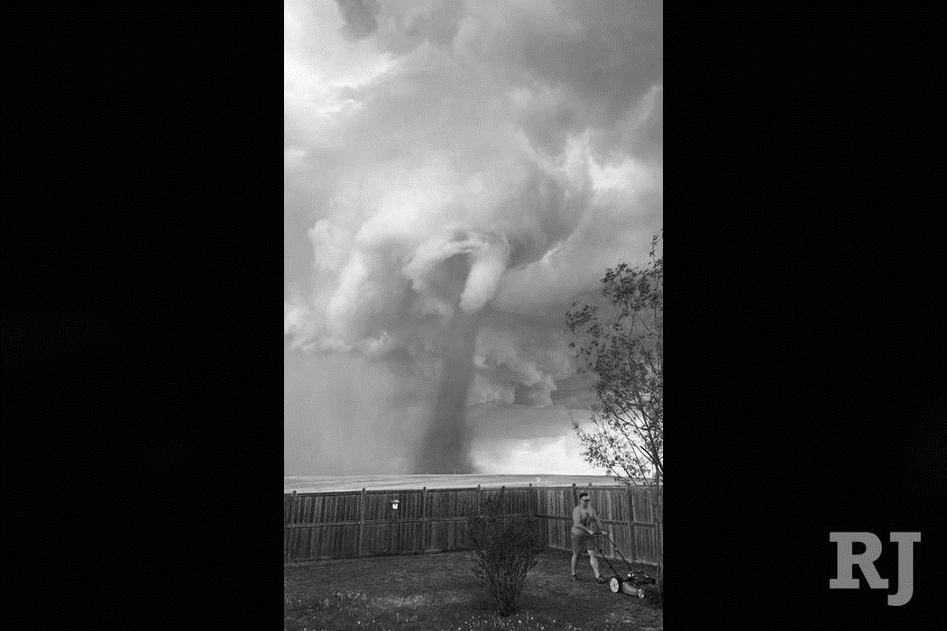

Through the use of visual elements, the photograph taken by Cecilia Wessels represents the idea that humans are oblivious to their environment. It works as a parody of the unawareness of humans of human-induced climate change and destructive anthropogenic activity.

The tornado is positioned in the background and is shown through composition to be large, as the man is very small in comparison. This works to construct the tornado as threatening and menacing, representing destruction and danger. Also, the use of a low camera angle gives the tornado a sense dominance and power, again representing the tornado as a threat.

In contrast to this apparent danger, the man in the image is mowing the lawn. His posture is bent forward slightly with his back straight. This is the expected posture when operating a lawnmower, indicating that the man is mowing his lawn as normal and is not in a particular rush or apparent emergency. Furthermore, his clothing is very causal, with a simple t-shirt, shorts and sneakers. This adds to the man’s apparent casualness and lack of awareness in approaching the situation.

Throughout history, humans have never realised the impact of anthropogenic environmental destruction to a great extent. This includes global warming, ocean acidification and deforestation. This text parodies this, exaggerating the obliviousness of humans to the environment by showing a man who is unaware of a tornado that is very close to him, which symbolises the effects of climate change.

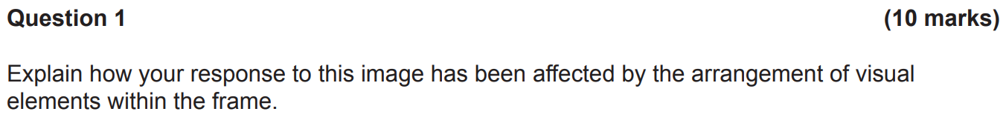

Through the use of visual elements, the still from the feature film Me and Earl and the Dying Girl represents the idea that there’s a missing connection between people of dark skin and people of white skin.

The composition of the image shows an empty seat between the subjects of different ethnicities, indicating a missing “link” that connects the two, perhaps the “dying girl” as referred to in the title of the film. The books in the background are symbolic of knowledge

[To be continued…]



Animals are represented in juxtaposing ways in Text 2, a passage from the novel River Runs by Stephen Scourfield, and Text 3, an extract from “Pets Allowed” by Patricia Marx.

Scourfield represents animals as dangerous predators that should be avoided by people. This is done by utilising a menacing voice. When describing the snake, Scourfield writes that it “syringes venom in calculated overdoses” into a lizard, which “froths at the mouth, cells saturated by poison”. Later, the snake would “squirt in more lethal sap”. This vivid description of the snake’s ability to kill portrays the snake in a menacing tone, as words such as “venom”, “overdoses”, “poison” and “lethal” all connote danger and threat. Also, when Vincent says “She can take in some poison. I’d’a been well dead by now” and “Don’t you get too close”, and when Dylan says “I don’t like them snakes. Should leave ‘em well alone”, this reference to the snake as something to be feared implies that animals should be left alone by people, contributing to the menacing tone to describe the snake.

Conversely, Marx represents animals as being overused as emotional support pets through the use of rhetorical questions and statistics. Marx describes emotional support pets as abundant and seemingly everywhere, writing “See the St Bernard slobbering over the spring onions at the supermarket? Isn’t that a Rottweiler sitting third row, mezzanine, at the Concert Hall?”. These rhetorical questions cause readers to start to question how many pets there actually are in the public and whether it’s much more than they realise. Furthermore, when Marx writes “What about the mental well-being of everyone else?”, she implies that one’s emotional support pet can be detrimental to another’s mental wellbeing, causing readers to question the overall effect of emotional support pets on health and further engaging the audience with the representation of animals as being overused as emotional support pets. Also, when Marx writes “in 2011 the National Service Animal Registry… signed up twenty-four hundred emotional-support animals. Last year, it registered eleven thousand”. This use of statistics aims to outline how absurdly high the number of emotional supports actually is, causing readers to question whether all the pets are actually necessary or whether some are using them as an excuse to bring a pet, adding to the representation of animals as being overused as emotional support pets.





Through the use of written and visual elements, the cover of the novel A Taxonomy of Love by Rachael Allen represents the concept of love as being complex in nature.

The written elements of juxtaposition colloquialism and font combined with the visual elements of composition and vectors outline the complexity of love. Although the title is "A Taxonomy of Love”, implying that love can be classified into categories, the composition and vectors on the cover imply that love is too complicated to be simply categorised. The many words are all equally sized and connected in a flow diagram manner. The majority of words have more than one line connecting it to another, and the equal sizing of words implies that each box is of equal importance and significance, endorsing just how hard it is to categorise love. This effectively conveys the message that love cannot be categorised, but is more of a web where one outcome can lead to many more outcomes, hence juxtaposing the title which implies that love can be categorised. Furthermore, the cover is written using a handwritten font. This suggests that this flow diagram is drawn by a person, creating a scholarly atmosphere as schools are the dominant environment where people would draw flow diagrams. Thus, this implies that the concept of love can be just as complex, if not more, as a subject learned in school, enforcing the representation of the concept of love as being complex in nature.

Through this use of multimodality, I can see that love cannot be categorised and can be very convoluted. Although the title tells me that love is simple, we can see through visual and written elements that it is not. The use of colloquialism creates a sense of familiarity between the book and the audience, which is most likely teenagers, establishing an emotional connection between them, while the composition and vectors of the cover still position me to interpret the concept of love as more complex than expected.